The VTTA Surrey/Sussex Group
Open 25 MILE TIME TRIAL on Sunday 15th September 2024
Promoted for and on behalf of Cycling Time Trials
under their rules and regulations.
- START SHEET -

Event secretary  David Pollard  2, Harison Road, Seaford  East Sussex BN25 3PN  Mobile 07973 420003  Email davepollard294@gmail.com | *** Event Headquarters ***  Fairwarp Village Hall,  Nursery Lane, Fairwarp,  East Sussex. TN22 3BD  On CTT Course no. G25/89 | Timekeeper & Recorder  Richard Meed  (Lewes Wanderers)  &  Peter Moon  (Eastbourne Rovers)

PRIZE VALUES

For veterans with the best plus on the current VTTA Age Adjusted times:

1st - £20, 2nd - £15, 3rd - £10. Fastest female Vet on Age Adjusted time: £20.00

Team with the best Plus on Age Adjustment £15.00 per rider

The ROBIN BUCHAN TROPHY will be awarded to the first member of the Surrey/Sussex Group on age adjusted
The POUND HILL TROPHY to be awarded to the first Club team of 3 Surrey/Sussex Group members on age adjusted times.
The 3 winning team members will also be awarded VTTA medals.

Fastest time overall: 1st - £20, 2nd - £15 Fastest female rider: £20

Please hang around after the event for tea and cake, and prize presentation

We will be using Resultsheet

The VTTA trophies and medals will be awarded at the Surrey/Sussex Group’s lunch in Feb 2025
at The Normandy Centre, Denne Road, Horsham RH12 1JF and it is hoped that the winners will be able to attend.

Please note the following points :

- Numbers will be available at the HQ which will be open from 6.30am. You must sign on before collecting your number and note the details of any special hazards on the course which will be displayed there.
- You must also now sign out when returning your number after your ride. Fail to do so and you will be shown as DNF
- London South District regulation - No vehicles, except those of the timekeepers and event officials, shall be parked in the vicinity of the starting and finishing areas.
- Competitors are requested not to warm up on any part of the course after the first rider has started.
- Riders must not cross the A22 in the vicinity of the start and finish areas.
- There are a number of roundabouts on the course and riders must exercise extra care, giving way to traffic from the right.
- No times given at the finish.
- CTT regulations require the compulsory use of a protective cycle helmet by riders aged under 18 in time trials. In the interests of your own safety Cycling Time Trials and the event promoters strongly advise all competitors to wear a hard/soft shell cycle helmet that meets internationally accepted safety standards.
- Working rear and front lights, either flashing or constant, should be fitted to your cycle in a position where it is clearly visible to following road users and is switched on for the duration of your ride in the event.
- Responsibility for taking the correct route rests with each rider, so please read the course details. Where marshals are positioned on the course they indicate the direction to be taken by riders but do not control the flow of traffic or indicate that it is safe for the rider to proceed. Please take care whilst riding and avoid becoming another accident statistic.
- Please only park at village hall.

CAR PARKING
There is only limited space for cars to park in the area in front of Fairwarp Village Hall.
Once this is full please only park on the left-hand side of Nursery Lane beyond the Hall and do not park in or obstruct the track which goes straight ahead at the right-hand bend. You can use the verge on the left-hand side of the road after the bend for additional parking. Do not do anything which might annoy the local residents as our future use of the Village Hall for the HQ is at risk if we get complaints. receve.

The VTTA Surrey/Sussex Group hope that you keep your head up and enjoy a safe ride.
If you are aged over 40 and are not already a member of the VTTA please consider joining
–the Event Secretary would be pleased to provide you with details or you can visit the VTTA website.

There are a number of roundabouts on the course. There will not be a marshal at them but the direction of the route will be clearly signed. Please familiarise before the event.

(Those wishing to go off course to get some extra miles in are asked to return their number before midday)

Course map

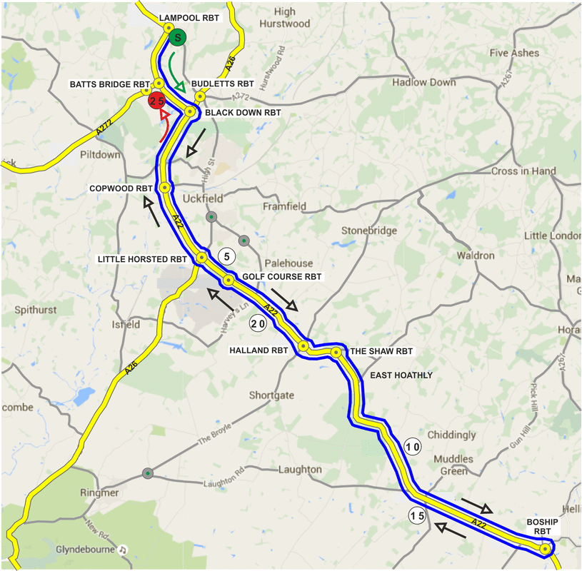

NUMBERS MUST BE FIXED BELOW WAIST
YOU ARE ALSO ADVISED NOT TO RIDE IN DARK CLOTHING

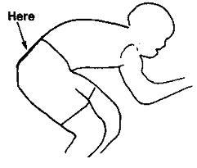

NO TIME MAY BE RECORDED IF NUMBER IS NOT CORRECTLY POSITIONED.

RIDE WITH YOUR HEAD UP!!!

